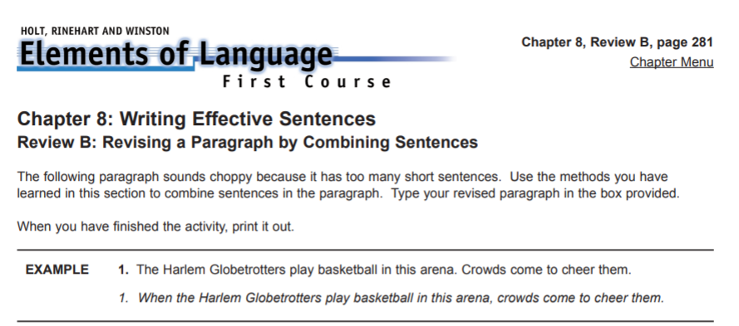
Dr. James Naismith invented the game of basketball over one hundred years ago. He probably never guessed the sport would become so popular. He just wanted a new game that could be played indoors. The original basketball teams started in 1891. They had nine players instead of five. The first basket was a peach basket. A player had to climb up and retrieve the ball after each score. Some parts of the game have stayed the same. Players still cannot hold the ball while they run. They must dribble. Thousands of teams across the world now play Dr. Naismith’s game.

